# See Stats

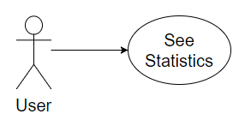

## Characteristic Information

|  |  |
| --- | --- |
| Superior business process: | Process-ID: refers to section 2.5.1 (business processes)> |
| Goal: | Is to get the Stats which you have a friend(number of messages sent/last call/last message/…) |
| Precondition: | Needs to have a friend in his friend list |
| Postcondition: | Saw interesting stats |
| Involved User: | The User sees what his stats with his friends are |
| Triggering Event: | When the user presses the see Stats button |

## GUI to call the use case

| Input field | Valid inputs |
| --- | --- |
| MessageTextBox | As in communicate with friends |

## GUIs for the standard use

| Step | User | Activity |
| --- | --- | --- |
| 1 | User | Start program |
| 2 | User | Look at the friends status |

## Scenarios for non-standard uses (bad cases or work around cases)

## GUIs for the non-standard uses

## Workflow

## Open Points